**DAILY ONLINE ACTIVITIES SUMMARY**

|  |  |  |  |  |  |  |  |  |
| --- | --- | --- | --- | --- | --- | --- | --- | --- |
| **Date:** | **16/06/2020** | | | | | **Name:** | **Anjali Manohar Prabhu** | |
| **Sem & Sec** | **4th Sem Section - ‘A’** | | | | | **USN:** | **4AL18CS007** | |
| **Online Test Summary** | | | | | | | | |
| **Subject** | | **COMPLEX ANALYSIS AND STATISTICAL METHOD** | | | | | | |
| **Max. Marks** | | **30** | | **Score** | | | **26** | |
| **Certification Course Summary** | | | | | | | | |
| **Course** | **E-Quiz on OPERATING SYSTEM** | | | | | | | |
| **Certificate Provider** | | | **N/A** | | **Duration** | | | **N/A** |
| **Coding Challenges** | | | | | | | | |
| **Problem Statement:**   1. Write a C Program to implement the Binary Reversal. | | | | | | | | |
| **Status: executed** | | | | | | | | |
| **Uploaded the report in Github** | | | | | **YES** | | | |
| **If yes Repository name** | | | | | **<https://github.com/vinisharen/lockdown-coding>** | | | |
| **Uploaded the report in slack** | | | | | **YES** | | | |

Online Test Details: MATH test was conducted on 16/06/2020 from 3:00 pm to 3:40 min with time limit of 40 min. There were 15 question in total and each question consist of 2 marks each. And the marks that I scored is 26/30.

SNAPSHOT: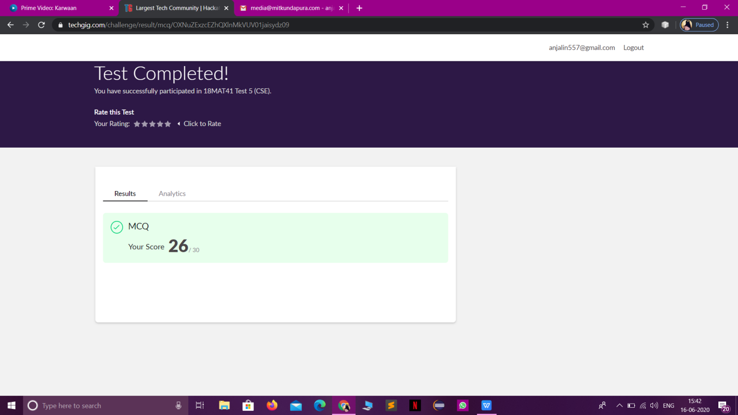

Certification Course Details: There was a E-Quiz exam on “OPERATING SYSTEM” conducted by the CSE department of “MOODLAKATTE INSTITUTE OF TECHNOLOGY (MIT) KUNDAPUR” have been provided with the certificate for attending the exam. Below there is the snapshot of the certificate.

**SNAPSHOT:**

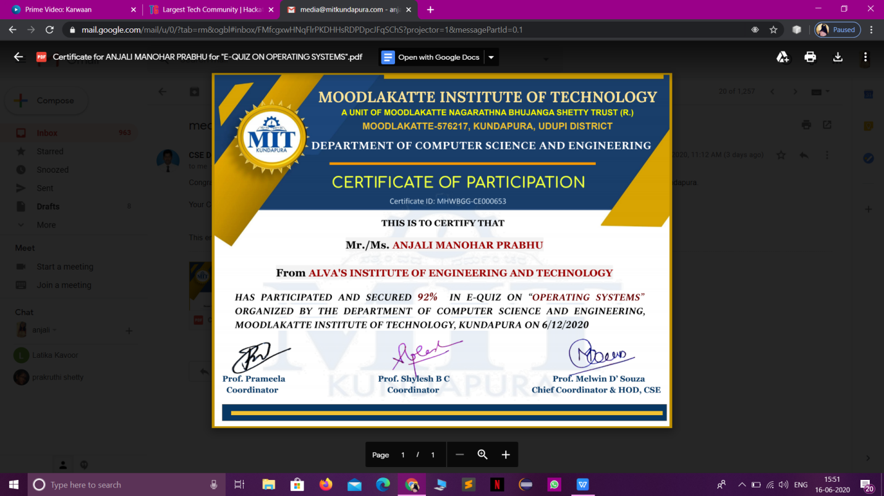

ONLINE CODING DETAILS:

PROBLEM 1: Write a C Program to implement the Binary Reversal.

**SNAPSHOT:**